Documentation

1. At first create a data base .
2. Import dairy.sql file under database folder in the database.
3. After importing sql file if you want to change database name , username, password than open db.php file and do change.

Login.php

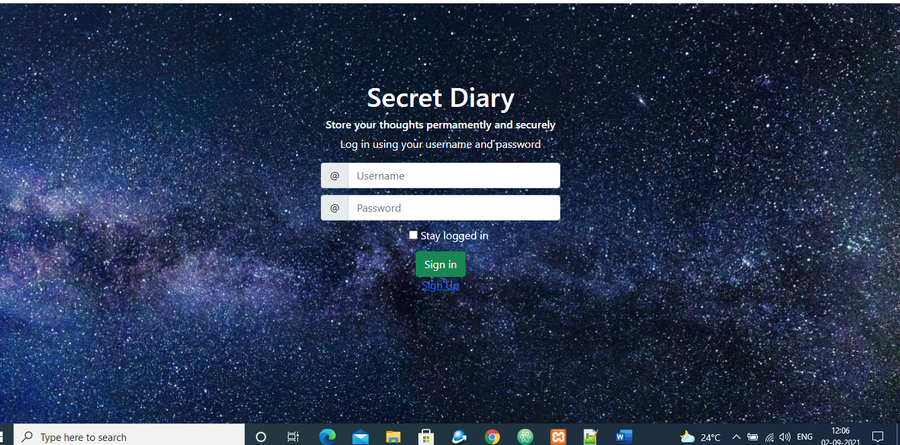

This is the login page where you can logged in and also sign up by clicking sign up link.

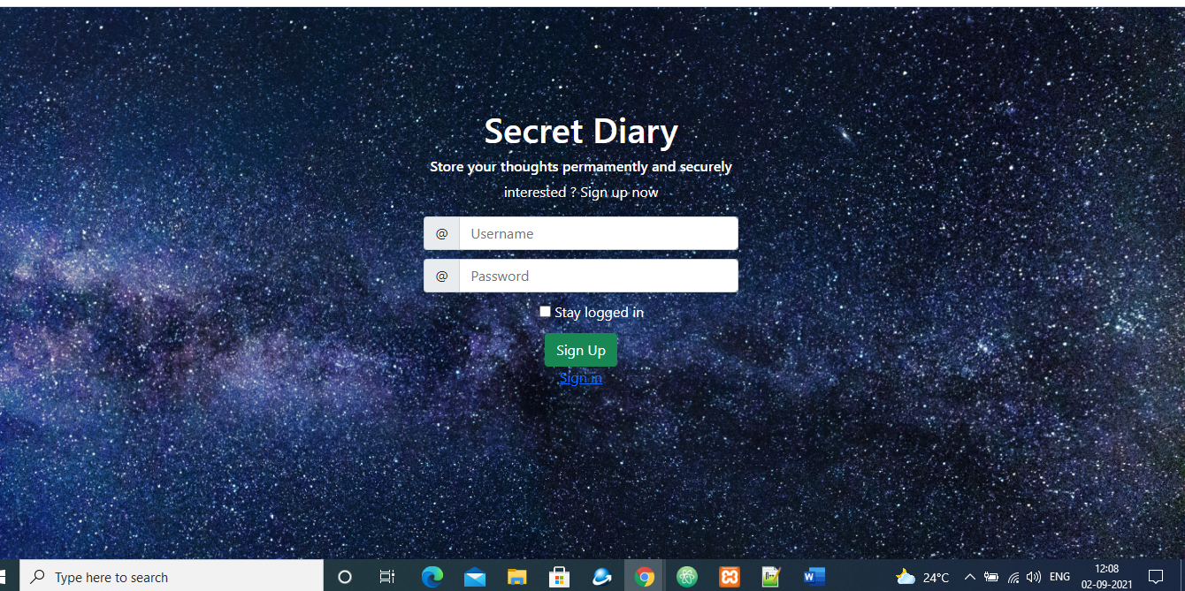

This is the sign up page where you can sign up and click to sign in and go to the sign in page where you can logged in.

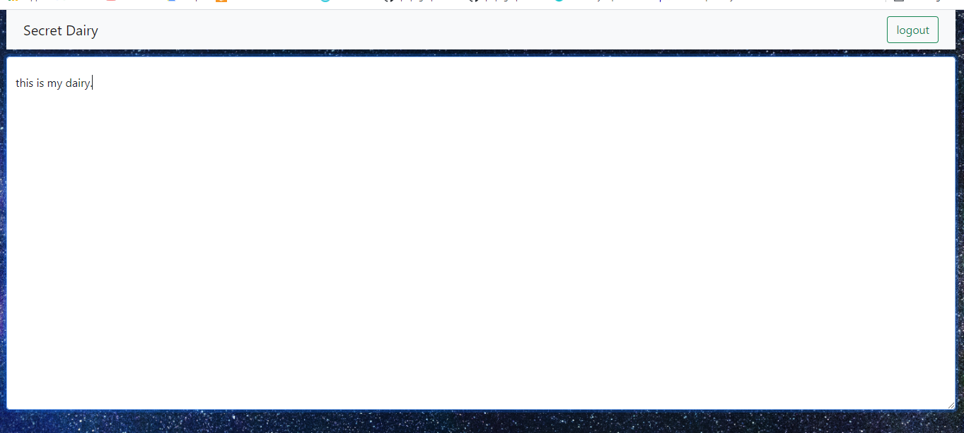

This is the dashboard where you can write and it automatically save.

You can logout by click logout button.

This is the project where I am adding all functionality where you explain in the documents and vedio.